**COLONIAL NEWS**

Health Committee Newsletter FEBRUARY 2025

Welcome to the Albert Gallatin School District Health Committee’s monthly newsletter. Each month this publication will provide our district with health and fitness information. Our goal is for our students, families, and staff to use this information to make healthy decisions and to live a healthy active lifestyle.

## **Create a Home Gym**

You do not need expensive exercise gear and equipment to have a home gym. By making the most of what you already have, you can work out at home without breaking the bank.

* **Use cans or bottles as weights.** Make your own weights by using canned goods or by filling used soda bottles with water or sand.
* **Make your own resistance bands.** Old nylons or tights make great substitutes for resistance bands.
* **Use chairs and stools.** Chairs can work as props for doing certain exercises, such as leg lifts. A low, sturdy stool can be used for step training.
* **Hit the stairs.** Who needs a stair machine when you have the old-fashioned kind in your house? You can create your own stair workout by walking up and down your stairs. Play some music to keep you going, and increase your workout by a song each time.
* **Watch fitness videos on your TV, laptop or phone**. Try yoga one day and Pilates the next. Switching it up can keep you from getting bored.
* **Look for used equipment.** If you have a little money to spend, you can find deals on used fitness equipment at yard sales and thrift shops.
* **Invest in cheaper fitness items.** Buying a few small fitness tools can help you vary your workout. A fitness ball can help strengthen your abs and improve your balance. Use a jump rope for a great cardio workout.
* **Use technology.** Need a little help planning your workouts or staying motivated? Use smartphone apps or computer programs to help you plan and track your workouts. Many are free, and some cost just a small amount of money.

Source: ACSHIC

**Blood Pressure**

Your doctor probably checks your blood pressure at least once a year. But do you know what those numbers actually mean — and why they matter? Here are a few important things to remember:  
  
**1. You can have high blood pressure (hypertension) and not know it.** High blood pressure is called “the silent killer” because it often develops with no signs or symptoms. The only way to know for sure if you have it is to get your blood pressure checked. More than half of all US adults have uncontrolled high blood pressure and don’t know it.  
  
**2. The guidelines have changed**. In the US, high blood pressure is now defined as 130/80 mmHg or higher. The old rule was 140/90. Even if only one of the numbers is above normal, you have high blood pressure. This change helps doctors catch the disease sooner, before serious health problems like a heart attack or stroke happen.  
  
**3. Your daily habits could be making things worse.** Unhealthy habits like smoking, eating lots of sodium, and not getting enough exercise can make your blood pressure soar. While many people need medication to keep their blood pressure under control, improving your lifestyle can make a big difference.

Source: ACSHIC



Prepared by Lisa Sumey, Central Office Secretary

**Recipe of the Month**

Healthy Turkey Meatballs

**Ingredients**

1 lb lean ground turkey 1 tsp dried basil

1 large egg, beaten 1/2 tsp garlic powder

1/4 cup dried bread crumbs 1/2 tsp onion powder

1/4 cup Parmesan cheese 1/2 tsp salt

1 tsp dried parsley 1/4 tsp pepper

Optional Sauce

1 cup ketchup

4 Tbsp brown sugar

1 1/2 tsp dried mustard

**Instructions**

* Prepare a large baking sheet with parchment paper or foil and lightly grease it with nonstick cooking spray.
* In a large mixing bowl, combine all ingredients. Use a tablespoon to scoop meatballs and place them on the baking sheet.
* Broil for 7-9 minutes. Leave in the oven and bake 4-5 more minutes at 350 degrees to finish cooking through or add to marinara sauce to simmer for 15 minutes.
* If using optional sauce, combine the sauce ingredients in a small saucepan and bring to a light simmer. Add sauce to meatballs to serve or use the sauce as a dip for meatballs.

Source: ACSHIC

   
  
  
  
   
  
 

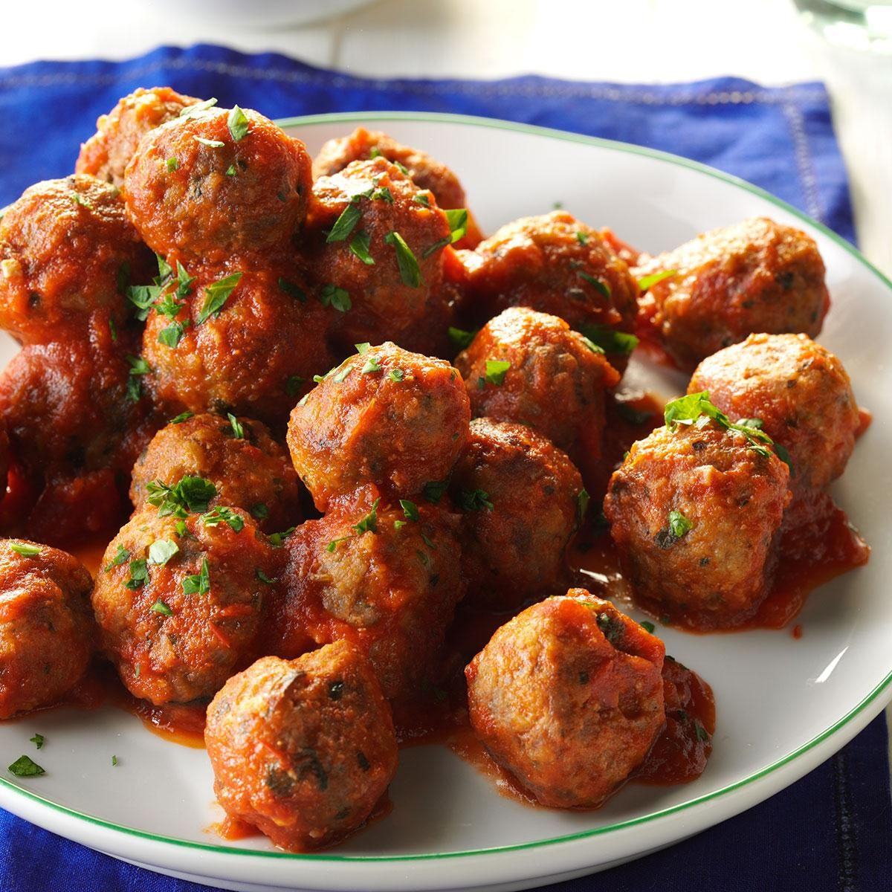

# Worry

Worrying can get the best of you. Chronic worrying can do more than mess with your rest. Studies show it can raise your risk for depression and anxiety and cause digestive issues, headaches, weight problems, forgetfulness, and more. Over time, it can even lead to high blood pressure, heart attacks, and strokes. Give yourself a rest from the anxiety, worry, and fear that can consume your thoughts. Here are a few tips to spend less time worrying and more time enjoying each day:

**Schedule worry time like a meeting.** You can’t avoid worries entirely, but you can keep them from taking over your brain space. Book yourself a 30-minute block of Worry Time every day. When you feel nagging thoughts creep in, jot them down on paper or your phone. Then when Worry Time comes along, pull out your list and allow yourself to give in to those thoughts — but only for 30 minutes. Any more fretting will need to wait until the next day. Bonus: Research proves that simply writing down your worries is one of the best ways to deflate their power.

**Lean into healthy habits.** Those caffeine jitters you feel when you’re on your third cup of coffee can make your worried thoughts worse. Try sipping on herbal tea (or decaf, in a pinch) instead. And don’t underestimate the power of exercise for your brain: Tons of research shows that whether you take a brisk walk or flow through a sweaty yoga class, movement can both improve your mental health and provide a distraction from your thoughts.  
  
**Take some deep breaths.** Science has proven that focusing on your breath regularly can help ease the anxiety and stress that can set off worries in our brains like dominoes.

Adapted from Source: ACSHIC